**PURBANCHAL UNIVERSITY**

**Biratnagar, Nepal**



**A PROJECT REPORT**

**ON**

**“BOOKSHOP MANAGEMENT SYSTEM”**

BACHELOR

IN

INFORMATION AND TECHNOLOGY (BIT)

**Submitted By: Submitted To:**

Dhiraj Karki  Purbanchal University Ishan Khadka

Manoj Ale

Sarfaraz Uddin

**Under the guidance**

**Of**

**Mr. PRAWESH DHUNGANA**

**HEAD, BIT**

**KIST COLLEGE OF INFORMATION AND TECHNOLOGY**

**Kamalpokhari, Kathmandu**

**KIST COLLEGE OF INFORMATION AND TECHNOLOGY**

**Kamalpokhari, Kathmandu**



**CERTIFICATE**

This is to certify that, DHIRAJ KARKI, ISHAN KHADKA, MANOJ ALE, SARFARAZ UDDIN of Bachelor in Information Technology (BIT) has studied as per the curriculum of BIT 2nd semester and completed the project entitled “ **BOOKSHOP  MANAGEMENT SYSTEM”.** This project is the original work of the people mentioned above of **KIST COLLEGE OF INFORMATION AND TECHNOLOGY** which was carried out under the supervision as per guidelines provided by Purbanchal University and certified as per the students declaration that project **“BOOKSHOP MANAGEMENT SYSTEM”** has not been presented anywhere as a part of any other academic work. The corrections and suggestions are already made/ done. The project report has been approved, as it satisfied the academic requirements in respect of the project work prescribed for the said degree.

 The details of the students are as follows:-

**NAME** **REGISTRATION. NO** **SYMBOL. NO**

Dhiraj Karki 058-3-2-02766-2019 311373

Ishan Khadka 058-3-2-02767-2019 311374

Manoj Ale 058-3-2-02794-2019 311381

Sarfaraz Uddin 058-3-2-02808-2019 311395

Course semester: -2nd semester

Subject: - Project-II

Subject code: - BIT

……………………………………..

Deepak Khadka

Program Coordinator, BIT



**KIST COLLEGE OF INFORMATION AND TECHNOLOGY**

**Kamalpokhari, Kathmandu**

**Examiner’s Certification**

A Project Report

On

**“BOOKSHOP MANAGEMENT SYSTEM”**

Developed by

**Dhiraj Karki**

**Ishan Khadka**

**Manoj Ale**

**Sarfaraz Uddin**

Is approved and is acceptable in qualify form.

……………………………….  …………………………………

**Internal Examiner** **External Examiner**

Name: Name:

Designation: Designation:

​

**ACKNOWLEDGEMENT**

It is with greatest satisfaction and euphoria that we are submitting our project report entitled “**BOOKSHOP MANAGEMENT SYSTEM**”. We have completed it as a part of the curriculum of **PURBANCHAL UNIVERSITY**.

We would also like to thank our Project Coordinator, **MR. DEEPAK KHADKA SIR, COORDINATOR OF BIT** for his constant support and assistance at every stage.

We would like to thank our Guide, **MR. PRAWESH DHUNGANA SIR, HEAD WORKER OF BIT** for his encouragement and support that helped us understand and complete this project on time.

We would also like to express our gratefulness towards **PURBANCHAL UNIVERSITY** for designing such a wonderful course structure. It will help us to get more knowledge in the field of Information Technology & help us to have a bright future in the field of technology.

We take this opportunity to thank our beloved Principal, **Dr. Dambar Singh Air** who has always been a great source of inspiration and encouragement for all the students.

Last but not the least, we would like to thank our parents, teaching and non-teaching staffs of our college and also our friends for always supporting us.

**DHIRAJ KARKI**

**ISHAN KHADKA**

**MANOJ ALE**

**SARFARAZ UDDIN**

**TABLE OF CONTENTS**

**Acknowledgement**.......................................................................…..**4**

**Abstract of the project**……………………………………………....**6**

**Introduction**………………………………………………………….**7**

**Objective of the project**……………………………………………..**8**

**System Requirements**………………………………………………..**9**

**System Design and implementation**

Algorithm………………………………………………………...**11**

Flowchart………………………………………………………...**20**

Use case Diagram………………………………………………...**38**

**Future Implementation of Project**………………………………....**39**

**Bibliography**………………………………………………………....**40**

**ABSTRACT**

This” **BOOKSHOP MANAGEMENT SYSTEM**” project aims to develop software for keeping different version of the book in the book store and selling and managing  the books in the book store.

This project is developed using simple file concept in C++ programming language, and is meant for recording book details and selling of the books similar to a book store . We have mainly focused on data file and function making in the project for the recording, editing and searching of the books in the book store.

Being beginners with  no practical experience in the field of software development, we limit the scope of our project by displaying books, adding books, editing book details, searching books, deleting books, calculating the bills while selling books in Bookshop Management System.

This program is focused made for beginner and medium type of learners. The professionals will find it easier and know what and how it has been done. It is a simple file concept C++ program.

**INTRODUCTION**

Bookshop Management System is a  simple software that manages all the information of books in the book store. This software helps in storing the records of the books in a simple manner.

This software “Bookshop Management System” includes different features like Displaying the books which are in the book store at the moment, editing the books information by their (name, author, stock, price), adding the books which are newly published in the store, searching the books in the store to see whether they are available or not. We can search the books by name, code, author. Also there are other features like deleting the books which are not available and damaged. Finally we can see how much our books are left in the store.

This program is made especially for the book store keeper, to remove the system of writing the sold items and recording them physically with pen and a paper. By this software their time is also managed and it will make their work also easier and convenient.

This program is encrypted so there is much more security. The user do not need to worry about the theft of their items and program. This software is very useful and can be used by any level of the user. It is a simple C++ program.

**OBJECTIVES**

* To develop a high digitized details maintenance in the book store to analyze and improve the store activities.
* To eliminate mathematical errors due to manual entry.
* To easily calculate the daily sales without error.
* To provide high security.
* To save time and accuracy while working.
* To store the details of the items permanently in the system.
* To make the valuation easy of quantities at hand.
* To know the quantities of books which are left-out in the store.

**SYSTEM REQUIREMENTS**

**MINIMUM REQUIREMENTS:-**

**Hardware:**

PROCESSOR: PENTIUM – II

SPEED: 1.5HZ

RAM: 32MB

HARD DISK: 20GB (AT LEAST 80 MB OF FREE SPACE)

**Software:**

WINDOWS: WINDOWS XP, 2000 PROFESSIONAL

**RECOMMENDED REQUIREMENTS:-**

**Hardware:**

PROCESSOR: I3 PROCESSOR

SPEED: 1.7HZ

RAM: 1GB

HARD DISK: 80GB (AT LEAST 200MB OF SPACE)

**Software:**

WINDOWS: WINDOWS 7, WINDOWS 10

**DEFINED CLASSES**

class book

{

public:

int book_num;

char book_name[25];

char book_aur[30];

int book_stk;

int book_price;

};

class admin

{

public:

char id[25];

char pass[25];

};

**ALGORITHM**

**Algorithm for starting program and main menu:**

STEP 1: Start.

STEP 2: Call title page.

STEP 3: Call login page.

* If username and password matches goto step 4.
* If username and password doesn’t match for 3 times, exit program.

STEP 4: Call main menu and display menu;

* 1. Administrator
* 2. Show All Books
* 3. Buy Book
* 4. Search Book
* 5. Exit

STEP 5: Ask user to enter choice and goto the following choice but if users choose 5, end program.

STEP 6: If user enters wrong choice then goto default case and call main menu again.

STEP 7: Stop.

**Algorithm for Administrator:**

STEP 1: Start.

STEP 2: Declare the things which can be done in administrator menu.

STEP 3: Call login page.

* If username and password matches goto step 4.
* If username and password doesn’t match for 3 times, exit program.

STEP 4: Call admin menu and display menu;

* 1. Add Book
* 2. Edit Book Data
* 3. Delete Book Data
* 4. Change Admin Password
* 5. Exit To Main Menu

STEP 5: Stop.

**Algorithm for showing book data:**

STEP 1: Start.

STEP 2: Declare variables.

STEP 3: Call showdata function.

STEP 4: Open “book.txt” file in read mode.

STEP 5: Read all the data from the file.

STEP 6: Add all the new data from the file to a variable.

STEP 7: Display all the data from the file and variable (row).

STEP 8: Display the data from file in formatted manner.

STEP 9: Stop.

**Algorithm for Buying Books:**

STEP 1: Start.

STEP 2: Declare variables.

STEP 3: Call title function.

STEP 4: Open “book.txt” file in append mode.

STEP 5: Ask user to input book code.

STEP 6: Ask user to input book quantity.

STEP 7: Check if code exists, if yes then goto step 5.

STEP 8: Display the book name, price and total in an formatted mannner.

STEP 9: Ask user if they want to enter more books, if yes goto step 5, else do grand total.

STEP 10: Stop.

**Algorithm for Search Book Data:**

STEP 1: Start.

STEP 2: Declare variables.

STEP 3: Display following menu:

* 1. Search by Book Code
* 2. Search by Book Name
* 3. Search by Author
* 4. Exit to Main Menu

STEP 4: Ask user to enter choice.

STEP 5: If user enters:

* 1 🡺 Call search code function.
* 2 🡺 Call search name function.
* 3 🡺 Call search author function.
* 4 🡺 Go to main menu.

Else, if user chooses wrong choice then go to the step 3.

STEP 6: Stop.

**Algorithm for Search by Book Code:**

STEP 1: Start.

STEP 2: Declare Variables.

STEP 3: Open “book.txt” file in read mode.

STEP 4: Ask user to enter book code.

STEP 5: Compare entered code with the file item code i.e. [if(variable==object.book_num)].

STEP 6: If code exists display all the members of the book code in formatted manner.

STEP 7: else call search book data function.

STEP 8: Stop.

**Algorithm for Search by Book Name:**

STEP 1: Start.

STEP 2: Declare Variables.

STEP 3: Open “book.txt” file in read mode.

STEP 4: Ask user to enter book name.

STEP 5: Compare entered name with the file book name i.e. if(strcmp (variable, object.book_name)==0).

STEP 6: Display all the members of the given book name in formatted manner.

STEP 7: Call search book data function.

STEP 8: Stop.

**Algorithm for Search by Author:**

STEP 1: Start.

STEP 2: Declare Variables.

STEP 3: Open “book.txt” file in read mode.

STEP 4: Ask user to enter book’s author name.

STEP 5: Compare entered name with the file book name i.e. if(strcmp (variable, object.book_aur)==0).

STEP 6: Display all the members of the given book author in formatted manner.

STEP 7: Call search book data function.

STEP 8: Stop.

**Aldorithm for Adding Book:**

STEP 1: Start.

STEP 2: Declare variables.

STEP 3: Enter the new book id and compare it with the old id’s in the file.

STEP 4: If old id display code exists goto step 3, else enter the following:

* 1 🡺 Book Name.
* 2 🡺 Book Author.
* 3 🡺 Stock Of Book.
* 4 🡺 Price Of Book.

STEP 5: Write the new data in file“book.txt” in append and add mode.

STEP 6: Ask user if he wants to add more data,

STEP 6: If yes goto step 3,else call admin menu function.

STEP 6: Stop.

**Algorithm for Edit Book Data:**

STEP 1: Start.

STEP 2: Declare variables.

STEP 3: Open “data.txt” file in read+ mode.

STEP 4: Rewind the file.

STEP 5: Ask user for the book code to edit.

STEP 6: Check if the book code exists, if yes goto step 7, else goto step 5.

STEP 7: Display the members of the book code and ask user do they really want to edit the data, if yes display:

* 1. Edit Book Name
* 2. Edit Book Author
* 3. Edit Book Stock
* 4. Edit book Price

And goto step 8, else goto main menu.

STEP 8: Ask user to enter choice.

STEP 9:

If user choice is 1:

* Ask user for new book name.
* Using seekp modify the name from the file.

If user choice is 2:

* Ask user for new book’s author.
* Using seekp modify the author from the file.

If user choice is 3:

* Ask user for new book stock.
* Using seekp modify the stock from the file.

If user choice is 4:

* Ask user for new book price.
* Using seekp modify the price from the file.

STEP 10: Modify the data and Call admin menu.

STEP 11: Stop.

**Algorithm for Delete Book Data:**

STEP 1: Start.

STEP 2: Declare variables.

STEP 3: Display following menu:

* 1. Delete a Data
* 2. Delete All Data
* 3. Exit to Main Menu

STEP 4: Ask user to enter choice.

STEP 5: If user enters:

* 1 🡺 Call delete s function.
* 2 🡺 Call delete all function.
* 3 🡺 Go to main menu.

Else, if user chooses wrong choice then go to the step 3.

STEP 6: Stop.

**Algorithm for Delete A Data:**

STEP 1: Start.

STEP 2: Declare variables.

STEP 3: Open “book.txt” in read mode and “temp.txt” in write mode.

STEP 4: Ask user to input book code to delete, if found goto step 5, else display “error opening file” and goto main menu.

STEP 5: Copy all the data from “book.txt” to “temp.txt” expect the members of given item code.

STEP 6: Remove “book.txt”.

STEP 7: Rename “temp.txt” to “book.txt”.

STEP 8: Display “Data Deleted ”.

STEP 9: Go to main menu.

STEP 10. Stop.

**Algorithm for Delete All Data:**

STEP 1: Start.

STEP 2: Open “book.txt” in read mode and “temp.txt” in write mode.

STEP 3: close both the files.

STEP 4: Remove “book.txt”.

STEP 5: Rename “temp.txt” to “book.txt”.

STEP 6: Display “All Data Deleted Successfully” .

STEP 7: Go to main menu.

STEP 8: Stop.

**Algorithm for Changing password:**

STEP 1: Start.

STEP 2: Declare the variables.

STEP 3: Open “login.txt” file in read mode.

STEP 4: Ask user to enter existing password.

STEP 5: Compare the existing password, if it matches goto step 6, else invalid password displayed and go to main menu.

STEP 6: Open “login.txt” file in write mode and ask user to enter new username and password

STEP 7: write the new password and username in file and close it.

STEP 8: Go to main menu.

STEP 9: Stop.

**FLOWCHART**

**Flowchart of main function**

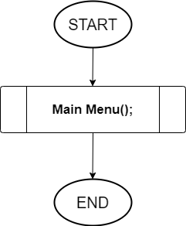

**Flowchart of login function**

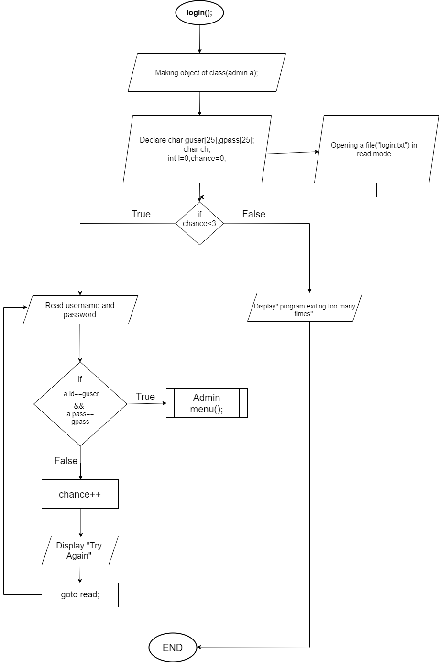

**Flowchart of main menu function**

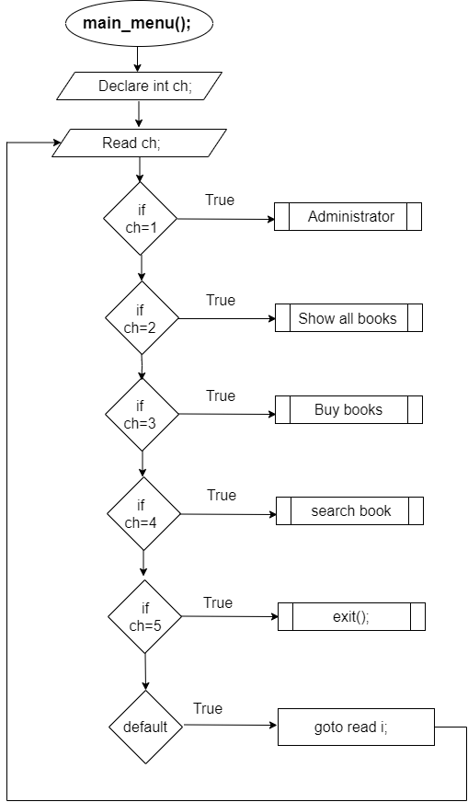

**Flowchart of buy book function**

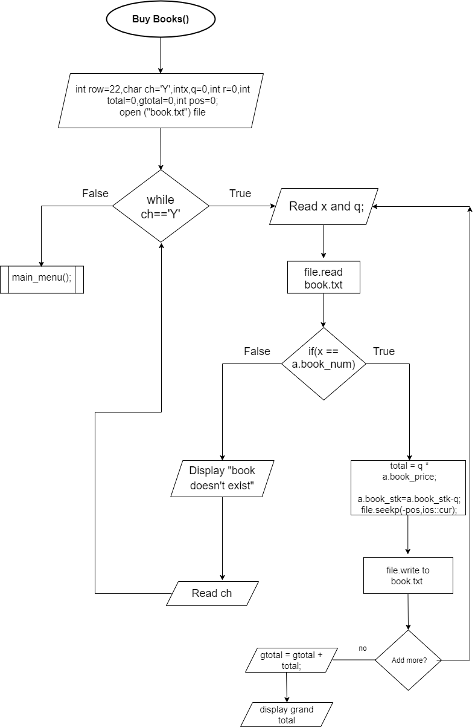

**Flowchart of add_books function**

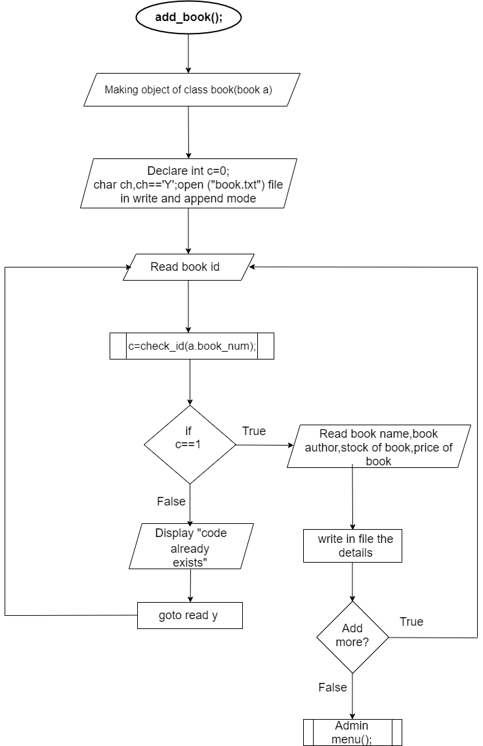

**Flowchart of int c_code( [ ] ) function**

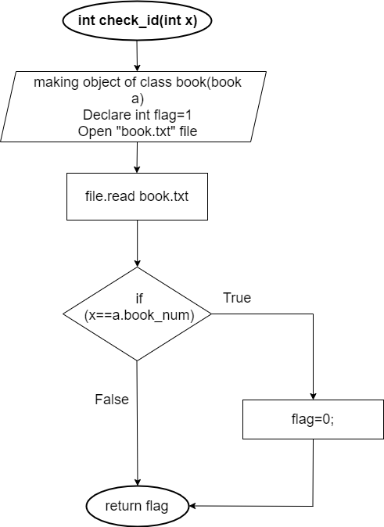

**Flowchart of edit book function**

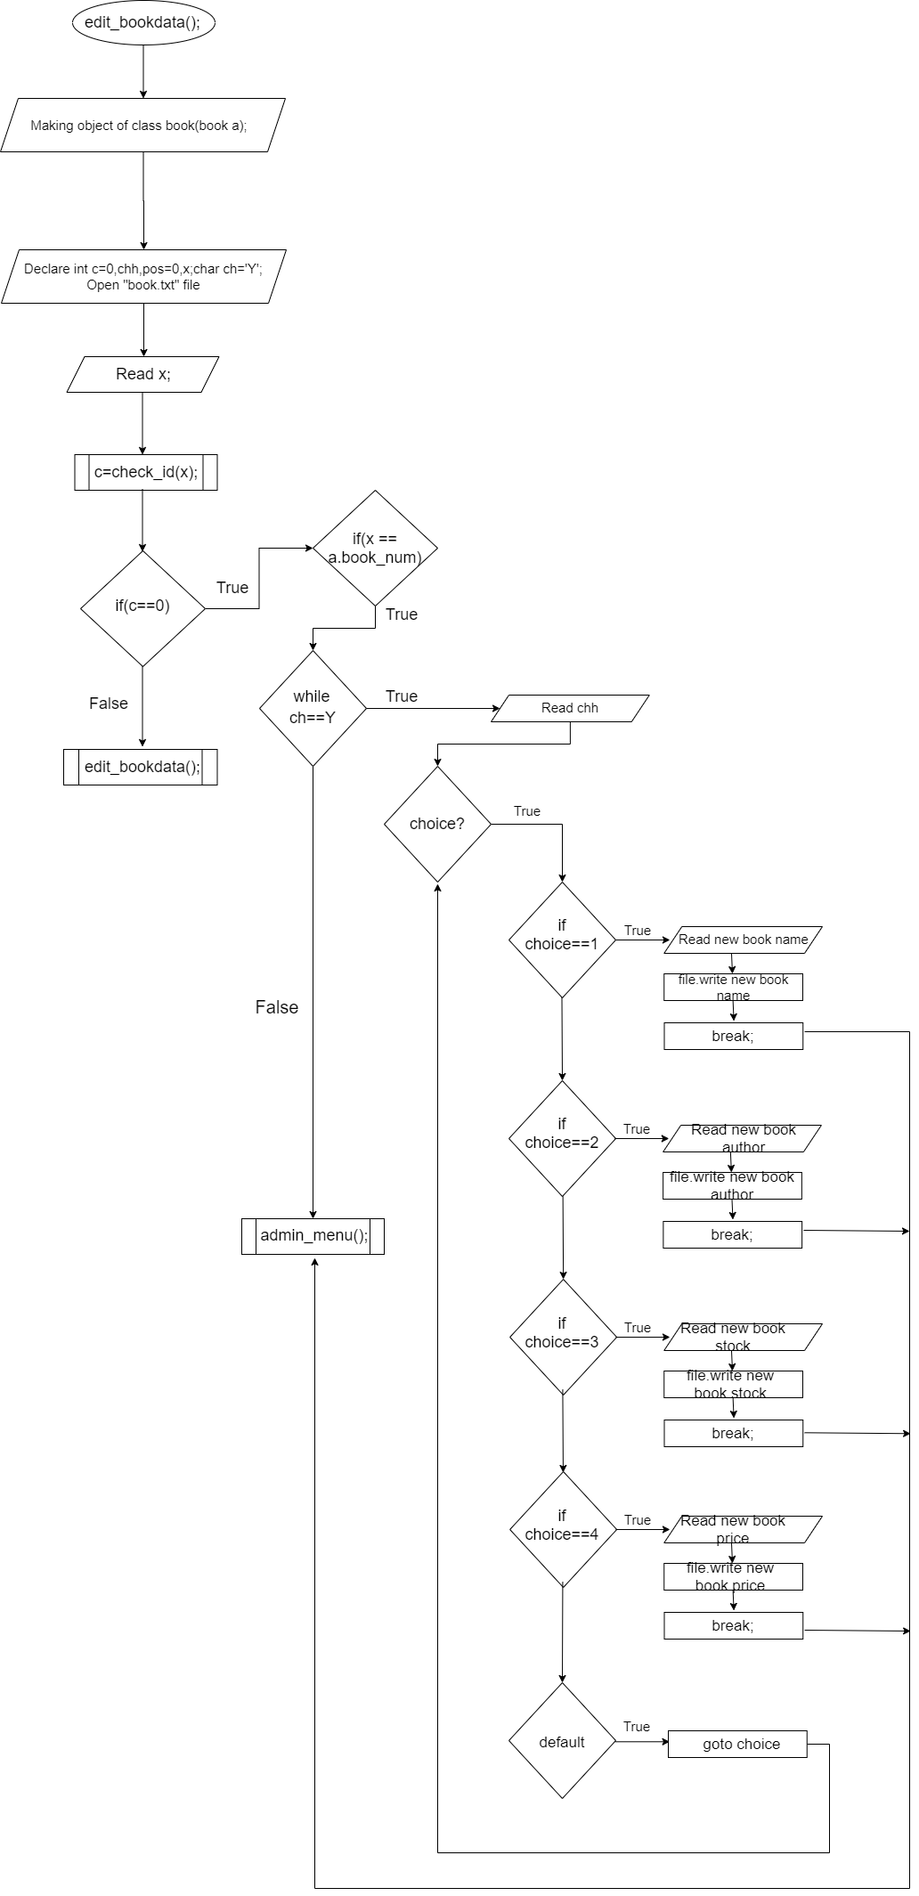

**Flowchart of delete book function**

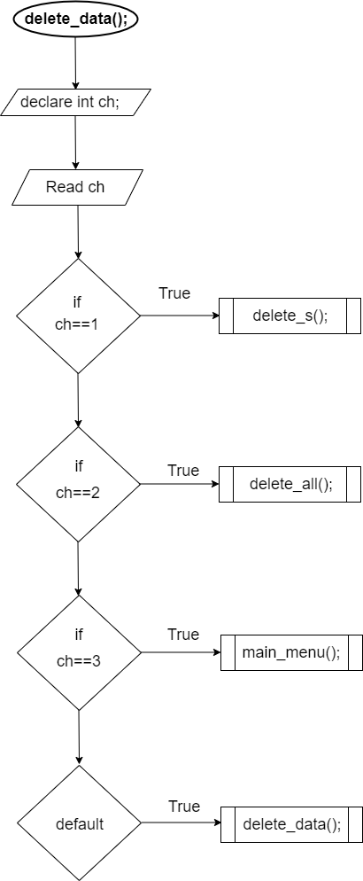

**Flowchart of delete_s function**

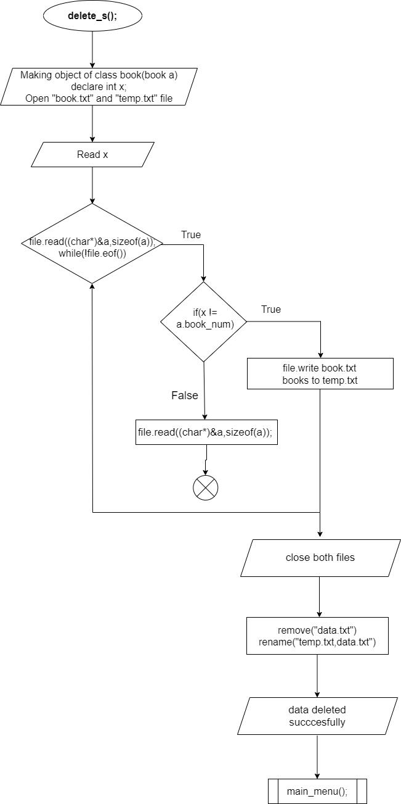

**Flowchart of delete_all function**

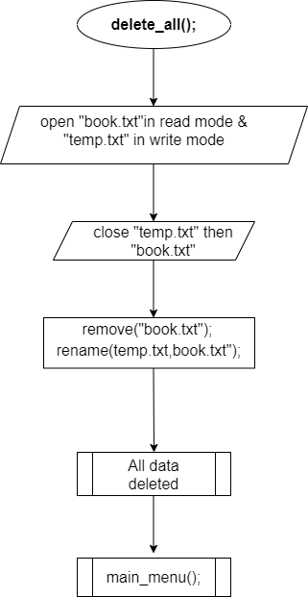

**Flowchart of search_books function**

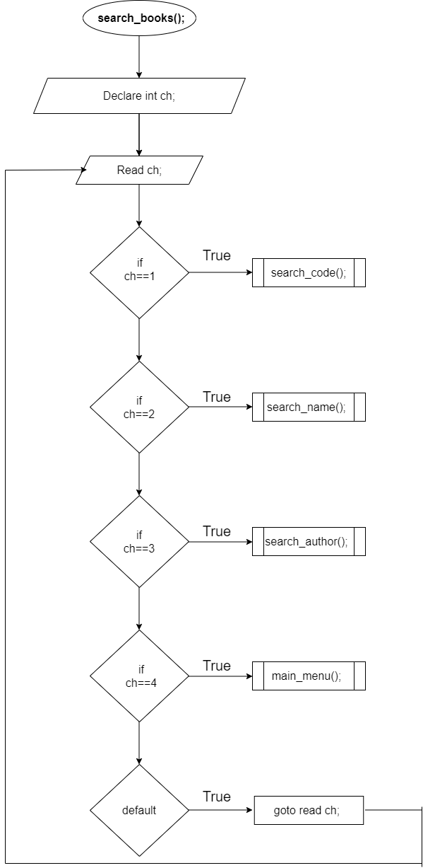

**Flowchart of search_code function**

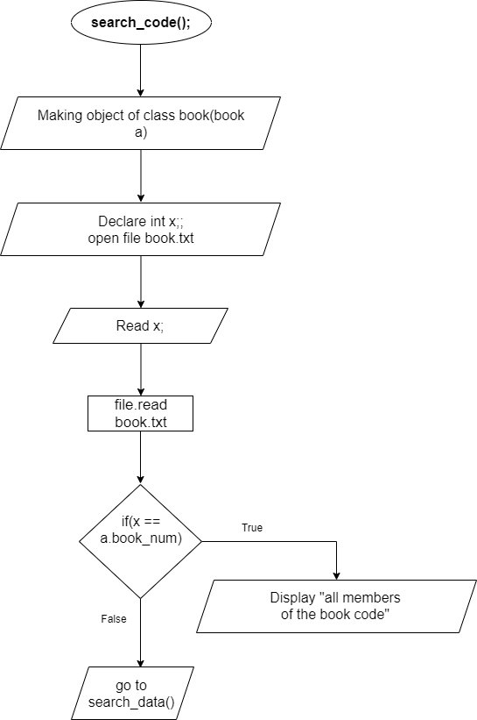

**Flowchart of search_name function**

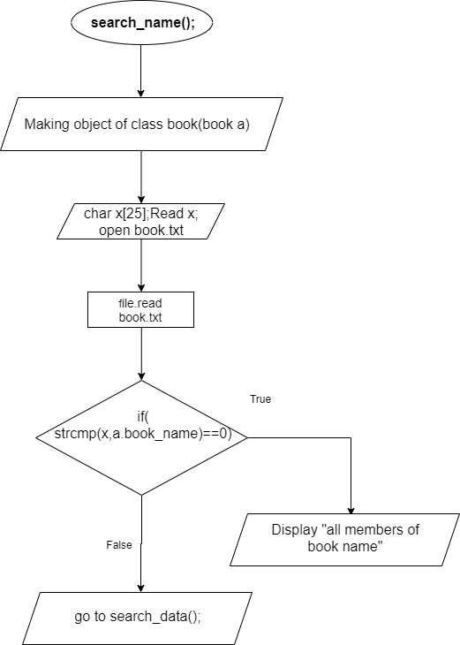

**Flowchart of search_author name function**

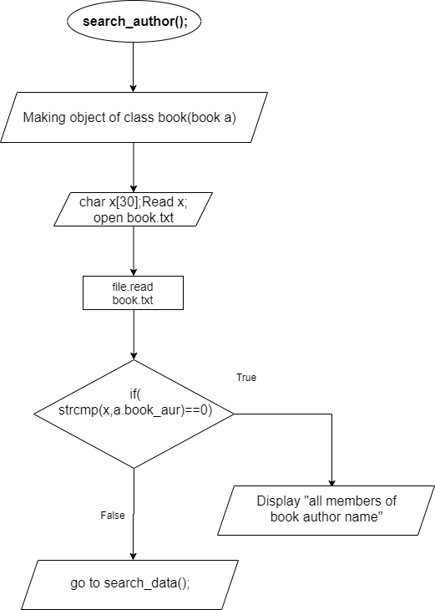

**Flowchart of admin menu function**

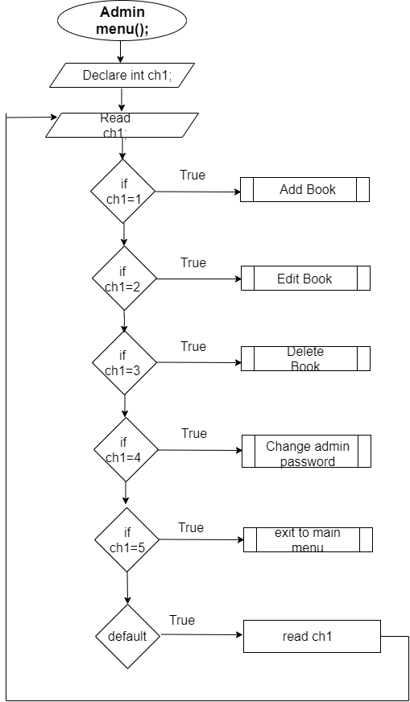

**Flowchart of change password function**

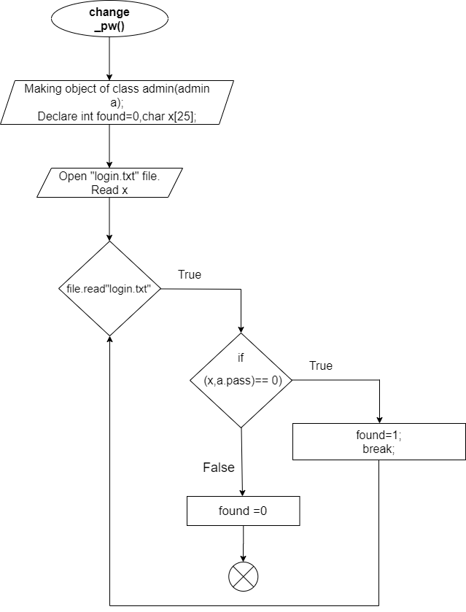

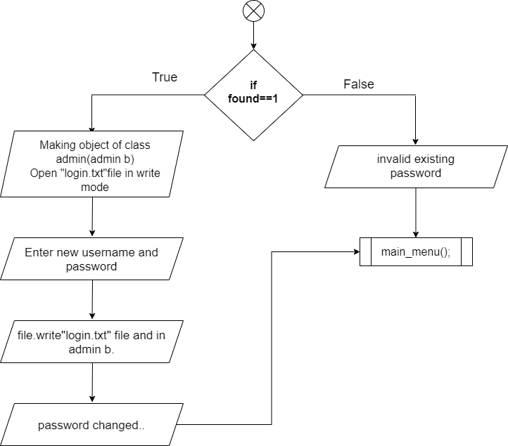

**Flowchart for end function**

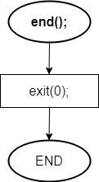

**USE CASE DIAGRAM**

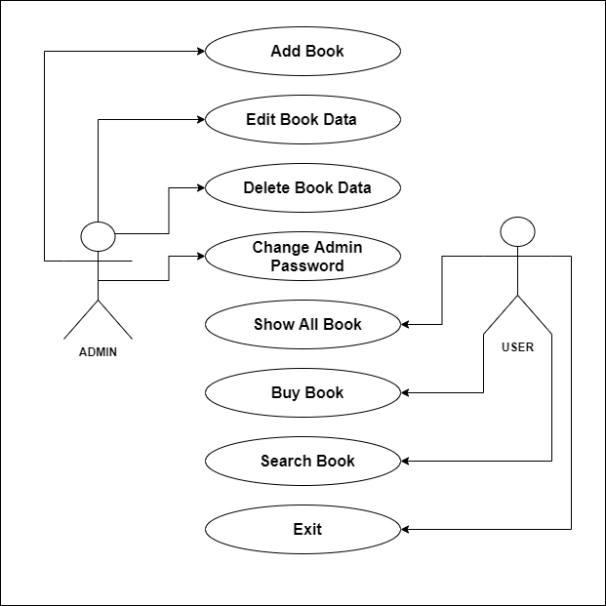

**FUTURE ENHANCEMENT**

This project is very simple program which is useful for different book store. Here, we checked/sold books and done calculations and recorded the books in the store. Also, the program records the books all together. It records in the same file and is easy to record. Here in this project, the protection mechanism is advanced we can change the password and username.

In future, we would also like to make a borrow system, from which people can take books for limited time. We would record the books with bar code system and also do the proceeding with the help of bar-code system. We would like to make it an website which will be very useful. After, it can be used by everybody. Also, we would add many features and upgrade the system and make the program more advanced. We will add features so that it will be easier and convenient for everyone.

**BIBLIOGRAPHY**

* Stack overflow
* C++programming
* [www.tutorialspoint.com](http://www.tutorialspoint.com)
* [www.geeksforgeeks.org](http://www.geeksforgeeks.org)
* [www.w3school.com](http://www.w3school.com)
* <https://draw-io.en.softonic.com/>